SIGNATURE #1
Join fellow leaders, educators, and community members in discussing the issues and opportunities facing our rural communities. See you at Rural Summit 2023 in Abingdon, VA on October 26 and 27. Learn more and register at unitedwayswva.org/ruralsummit23

SIGNATURE #2

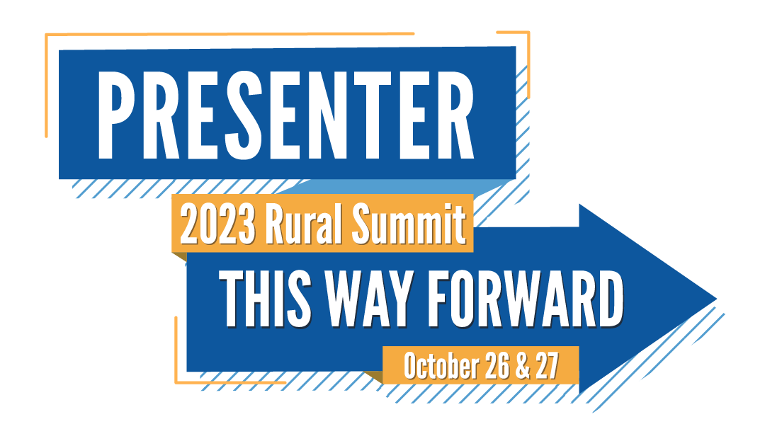 | I’m proud to be presenting at the 2023 Rural Summit. Leaders, educators, and community members will be brought together to address the issues and opportunities facing our rural communities. See you in Abingdon, VA on October 26 and 27. Learn more and register at unitedwayswva.org/ruralsummit23

SIGNATURE #3
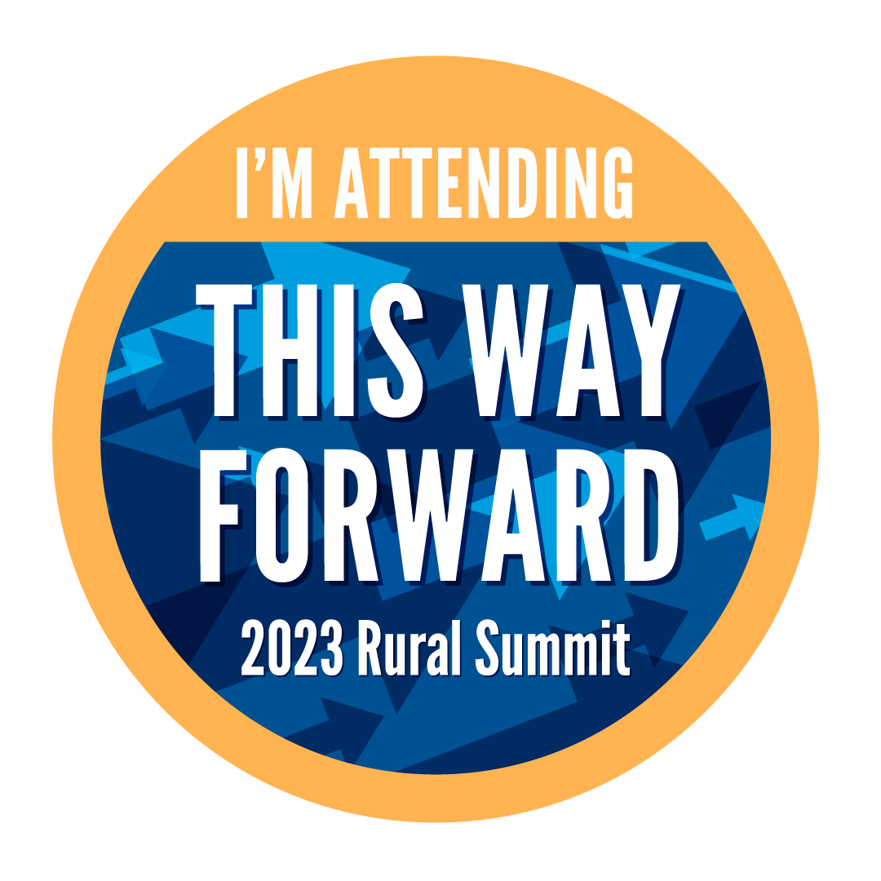
The Rural Summit brings together leaders, practitioners, educators, and community members to explore proven strategies for building resilient and prosperous communities in Abingdon, VA on October 26-27. Learn more and register at unitedwayswva.org/ruralsummit23

